**Z.O.O Report**

Group: ITEC Pantry

Jiaziruo Sun (101121503)

Shuheng Wang (101140312)

Xiaoman Lin (101137873)

Xinyin Zhang (101098426)

**Table of Content**

**Table of Content** 0

**1.0 What are we creating? Why?**1

**2.0 Project Content**2

2.1 Entities 2

2.2 Attributes 3

2.3 ER Diagram and EER Diagram 5

**3.0 Conclusion**6

**Reference**6

# 

# 

# 1.0 What are we creating? Why?

We are going to create a database for the largest zoo in Canada, Toronto Zoo. It has more than 5000 animals representing over 500 species. The animals are mainly classified into seven regions: Indo-Malaya, Africa, Americas, Tundra Trek, Australasia, Eurasia, and the Canadian Domain.[1] It opens many interesting activities like wild camping and scenic safari drive through. Visitors can have an immersive wild trip there.

For such a mass zoo, it’s important to manage everything in perfect order. They need to track animals, employees, and events to avoid occasional incidents. Our project Z.O.O will help them group and store all the information in a database, updating personnel changes and animals’ state and make it faster and easier to find an archive.

# 

# 2.0 Project Content

## 2.1 Entities (with subclass)

* Employee
  + Trainer
  + Security
  + Technician
  + Cleaner
* Animal
  + Africa
  + Americas
  + Australasia
  + Canada Domain
  + Indo-Malaya
* Department
* Service
  + Camping
  + Gift hop
  + Scenic Safari Drive thru
  + Walking route
* Visitor
* Payment method
  + Cash
  + Credit
  + Debit
* Ticket (weak entity)

## 

## 2.2 Attributes

* Employee
  + Name (composite)
    - First name
    - Middle name
    - Last name
  + Birthday (composite)
    - Year
    - Month
    - Day
  + Address (composite)
    - Street name
    - Street number
    - Postal code
  + Contact information (composite)
    - Email
    - Phone number
  + Salary
  + Age(derived)
  + Gender
  + ID (key)
  + Job_type
* Animal
  + Name
  + Age
  + Sex
  + Species
  + Preference (multivalued)
    - Diet
    - Environment
  + Domain
  + Quantity(derived)
  + ID (key)
* Department
  + Department code (key)
  + Phone
* Service
  + Opening hours (multivalued)
  + Phone number
  + Service Num (key)
* Visitor
  + Name (composite)
    - First name
    - Middle name
    - Last name
  + ID (key)
  + Age (derived)
* Payment method
* Ticket
  + Price
  + Overdue date (composite)
    - Day
    - Month
    - Year
  + Type
  + Ticket ID (key)

## 2.3 ER Diagram and EER Diagram

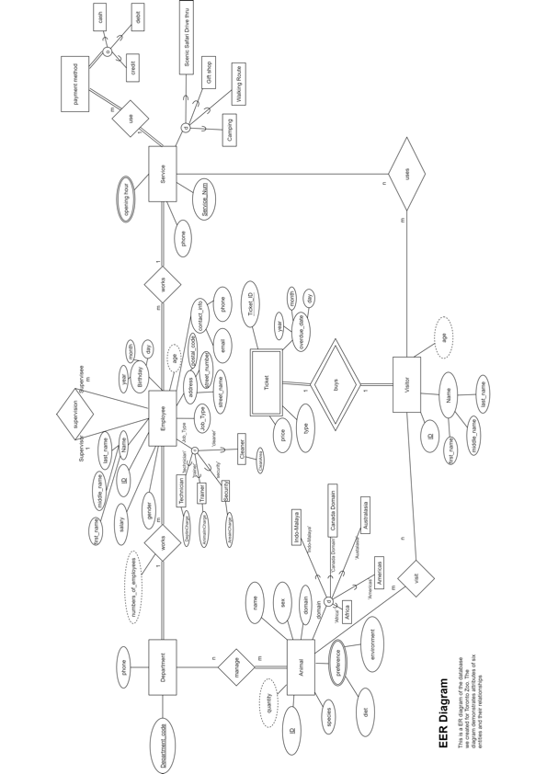

## 

# 3.0 Conclusion

Our team is aiming to establish a database of Toronto Zoo focusing on its information about the animals, employees, and other necessary functional data to help build a more efficient managing system. The database will provide the access of tracking information in three aspects: the animal archive, the employee archive and the daily visitor turnover.

One of the problems we faced while working on the proposal of the database was mainly about checking the practicality of the attribute and the type of them. For example, we discussed if “habitat” should be placed under the attribute “habit” or “habitat” should be a separate attribute; and we talked about if we should add an attribute of ticket code under the ticket entity. Another problem is since we are in different time zones which is hard to meet offline and work with the ER diagram together. We eventually decided to hold an online meeting to discuss and review the final entities and attributes in the database and let one group member share the screen when creating the diagram at the moment we were talking.

The future problems for our project might include the difficulties in programming, dealing with irrelevant or repeat data, and looking for the best way to filter data and further condense them to more useful information. Overall, our project Z.O.O. will provide a chance for Toronto Zoo to operate with orders and efficiency particularly on tracking animals, employees, and visitors, through classify and link all the needed information.

# Reference

“Toronto Zoo: Home.” Accessed September 25, 2020. <http://www.torontozoo.com/>

1. “Toronto Zoo: Home,” accessed September 25, 2020, <http://www.torontozoo.com/>.